**Project 3:**

**customer support chatbot using Amazon Lex V2**

**🛠 Step 1: Create the Lex V2 Bot**

1. **Open the Lex V2 Console**

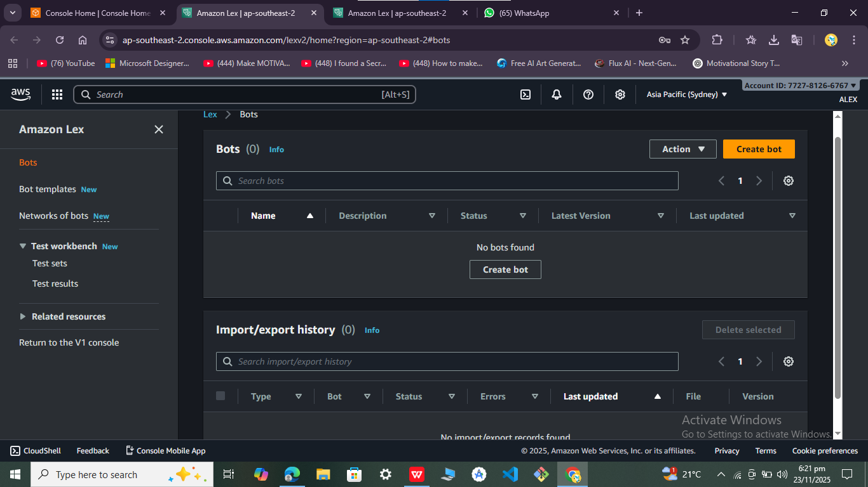

1. Configure the Bot

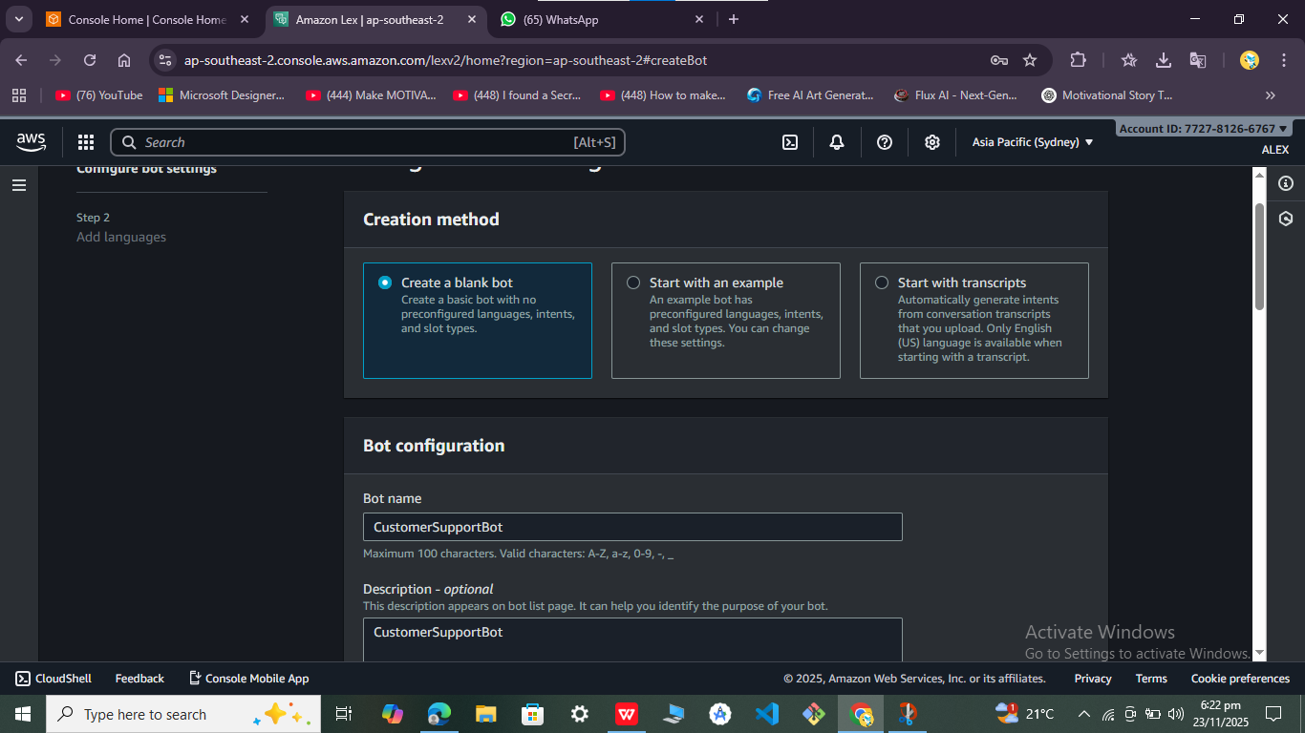

Step 1a: Create Multiple Intents

### Intent 1: ****OrderStatus****

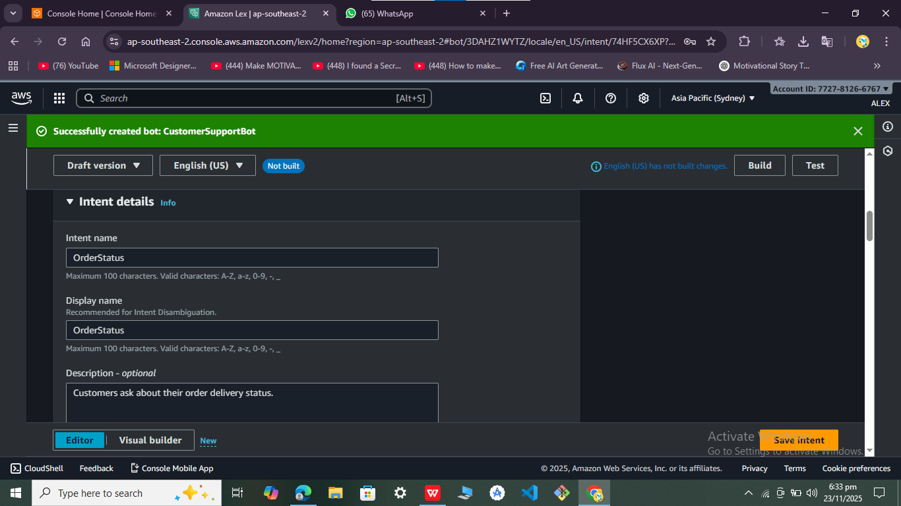

Intent 2: **RefundPolicy**

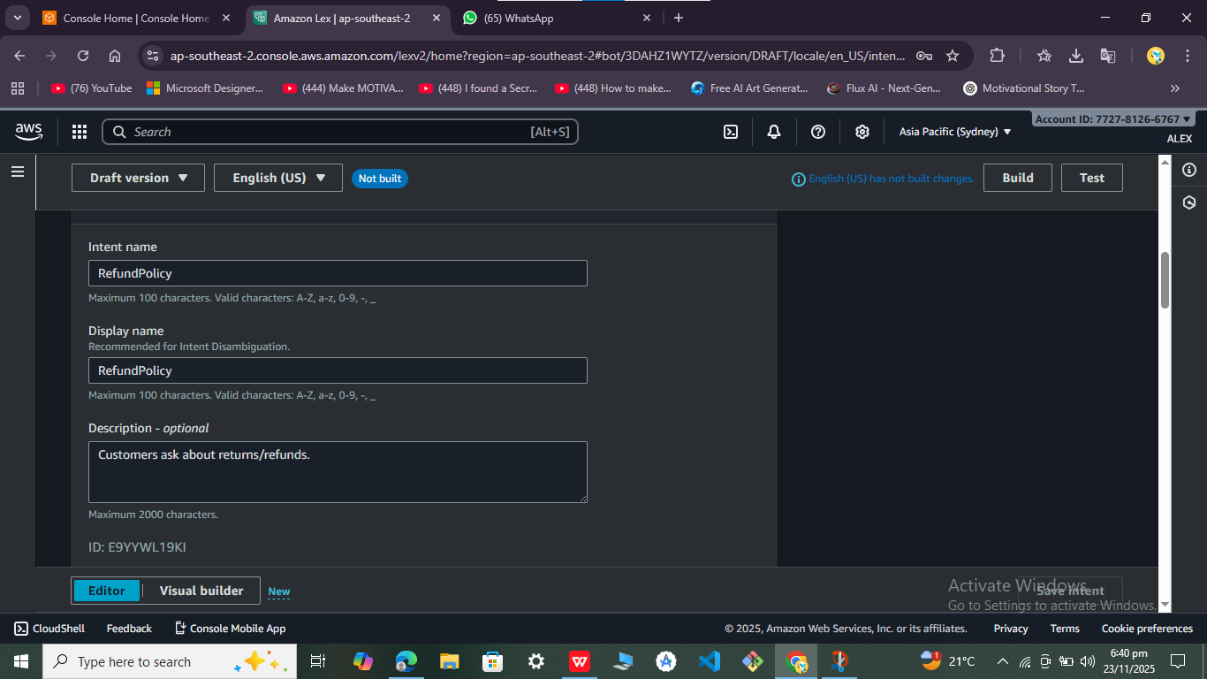

Intent 3: **ShippingInfo**

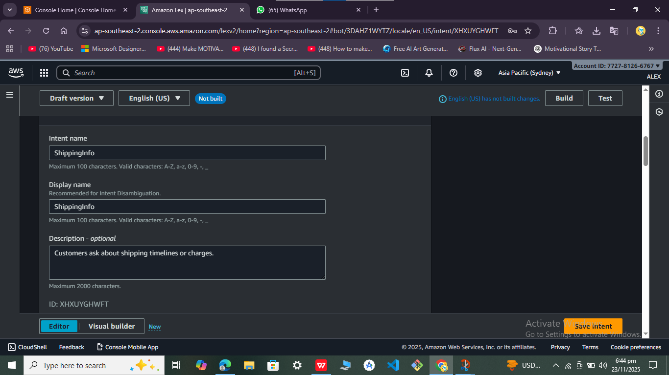

Build and Test

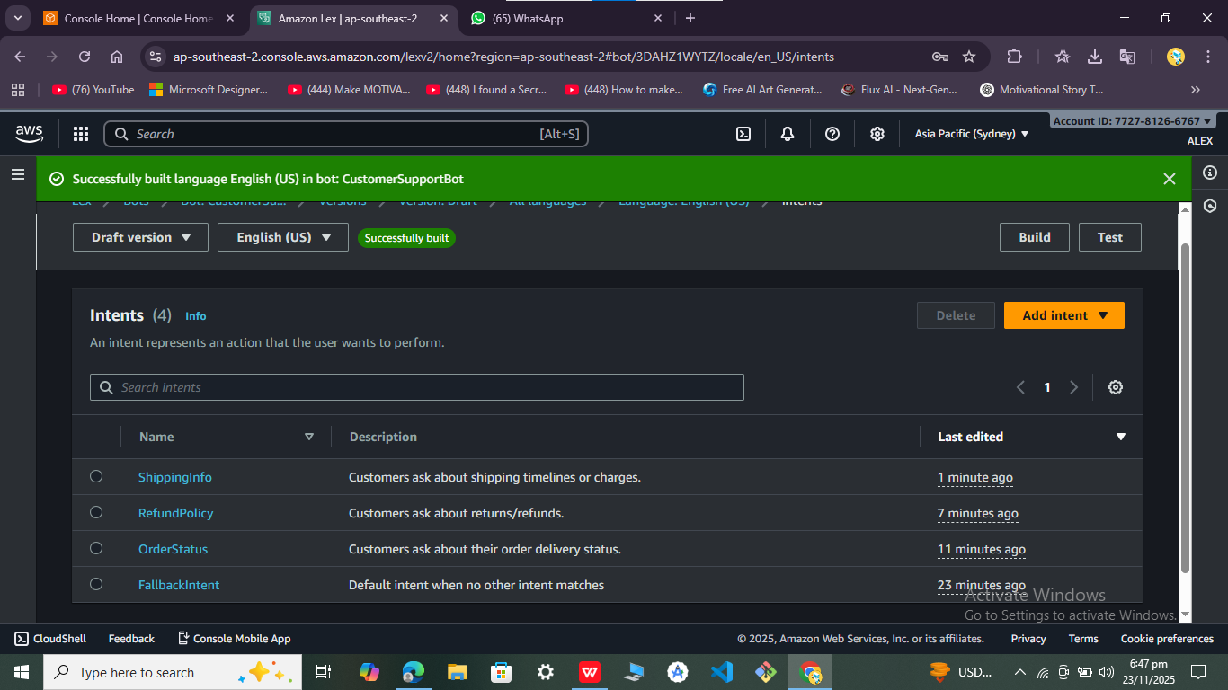

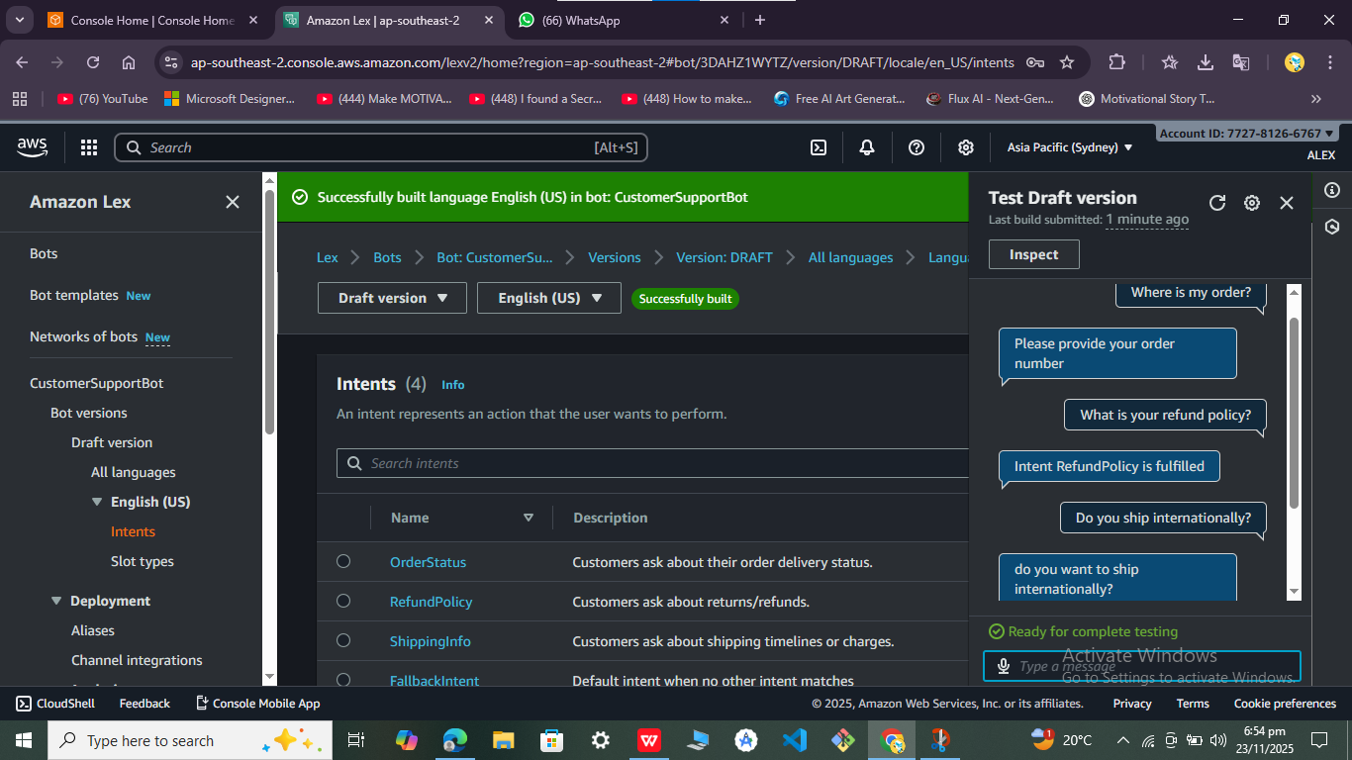

Step 2: Implement the Lambda Function

**Creating and configuring the Lambda function** for the Lex V2 bot. This is where your chatbot gets dynamic intelligence: instead of just static responses, it can validate inputs, fetch data, and return personalized answers.

1. Create the Lambda Function

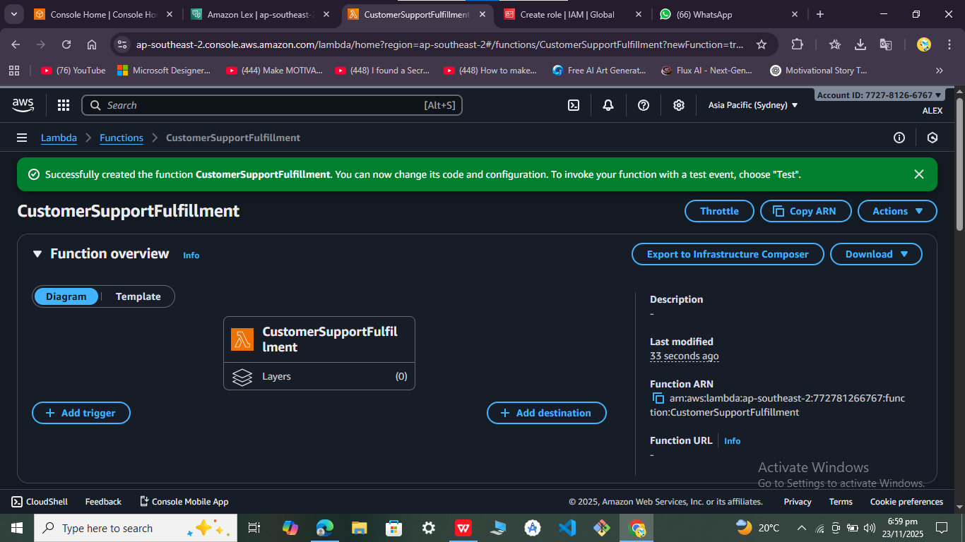

1. Write the Lambda Code

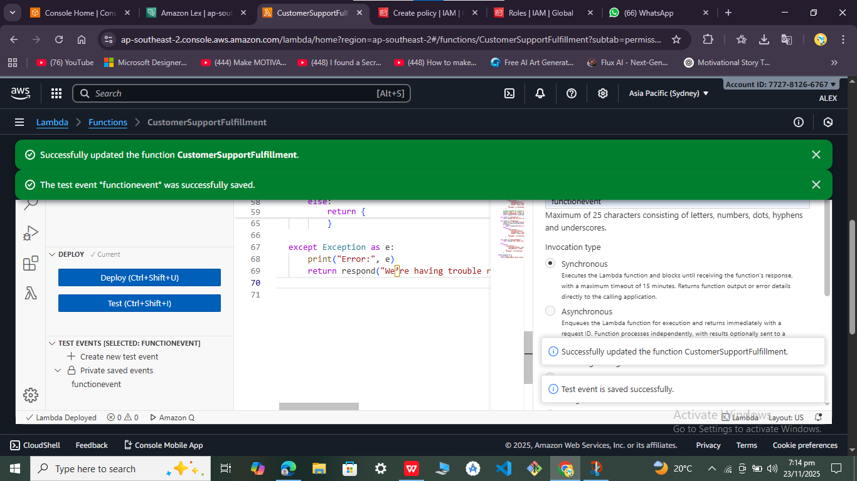

# 🛠 Step 2: Implement the Lambda Function

## Create the Lambda Function:

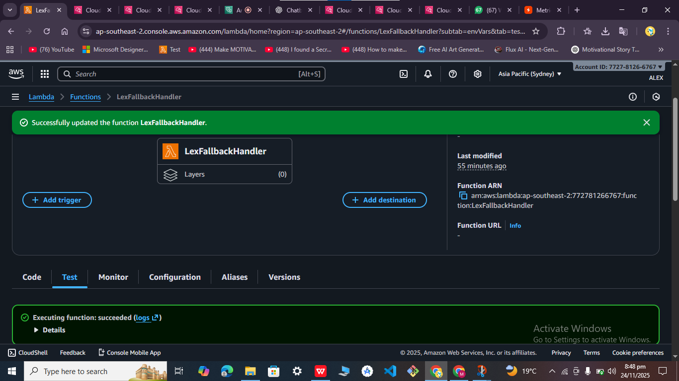

## 2. Understand Lex → Lambda Event Flow

When Lex calls Lambda, it sends an **event JSON** like this:

json

{

"sessionState": {

"intent": {

"name": "OrderStatus",

"slots": {

"order_id": {

"value": {

"interpretedValue": "12345"

}

}

}

},

"sessionAttributes": {}

},

"messages": []}

## 4. Deploy and Test

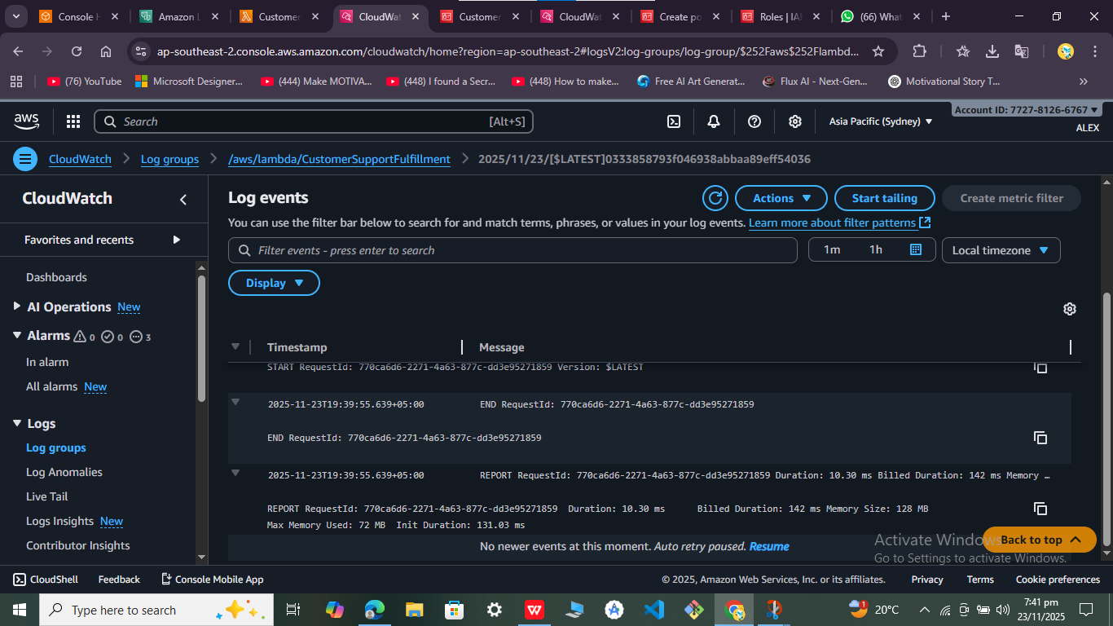

1. Connect Lambda to Lex

· In Lex V2 console, go to **Bot → Aliases → TestBotAlias**.

· Under **Code hooks**, attach your Lambda function.

For each intent:

* Enable **Initialization and validation code hook** if you want slot validation.
* Enable **Fulfillment code hook** if you want Lambda to generate the final response.

· Rebuild the bot.

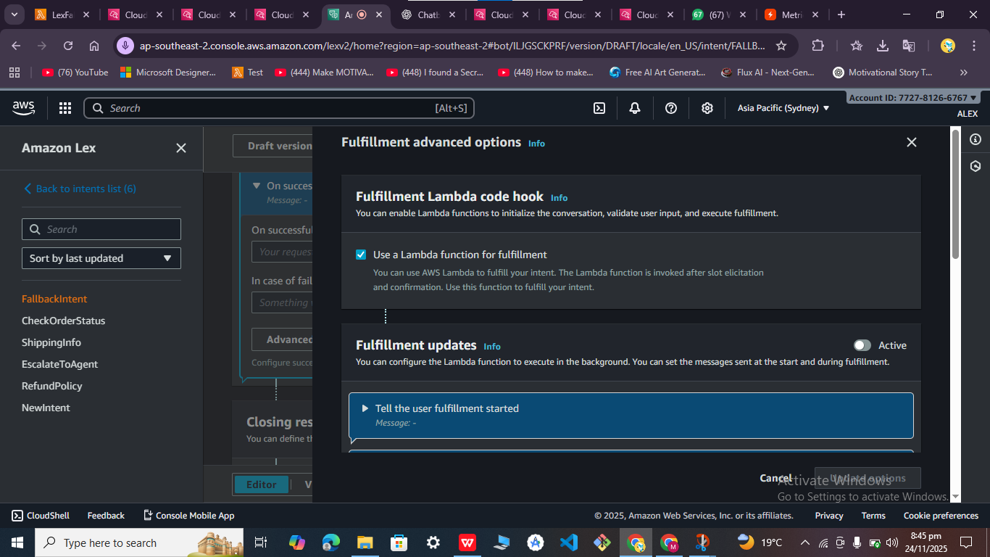

## Important next steps:

1. **Attach your Lambda to the alias** (TestBotAlias → Code hooks).
2. 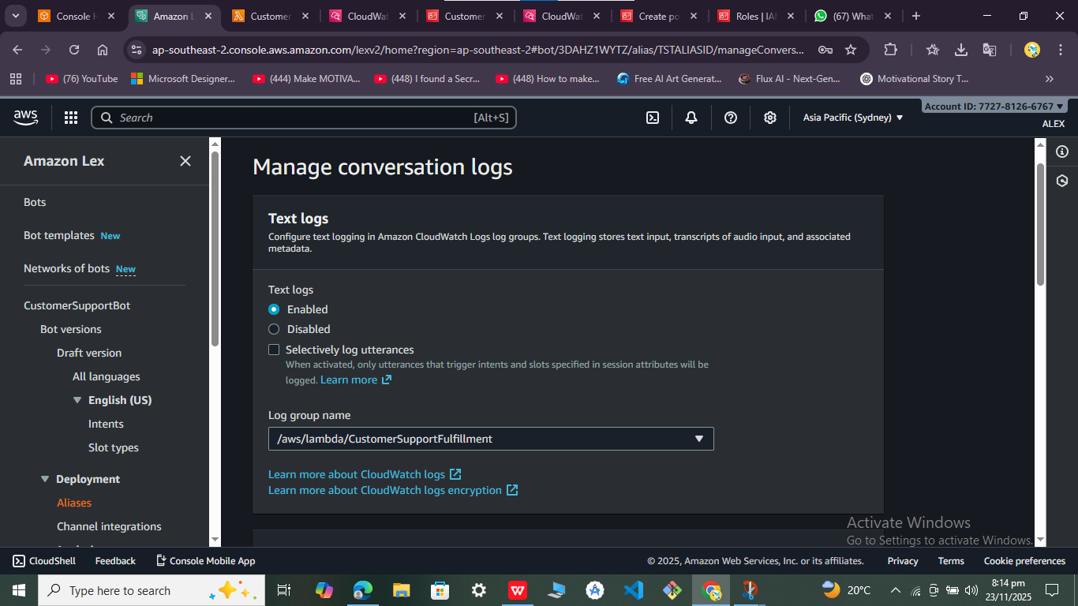

🛠 Step‑by‑Step: Enable Audio Logs:

1. Create or choose an S3 bucket:

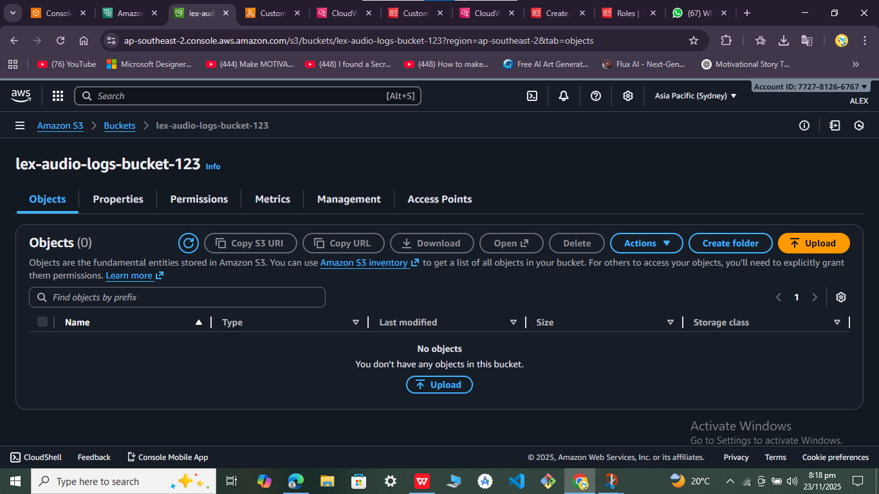

1. Attach permissions

{

"Version": "2012-10-17",

"Statement": [

{

"Effect": "Allow",

"Action": ["s3:PutObject", "s3:GetBucketLocation"],

"Resource": "arn:aws:s3:::lex-audio-logs-bucket/*"

} ]

}

1. Enable audio logs in Lex

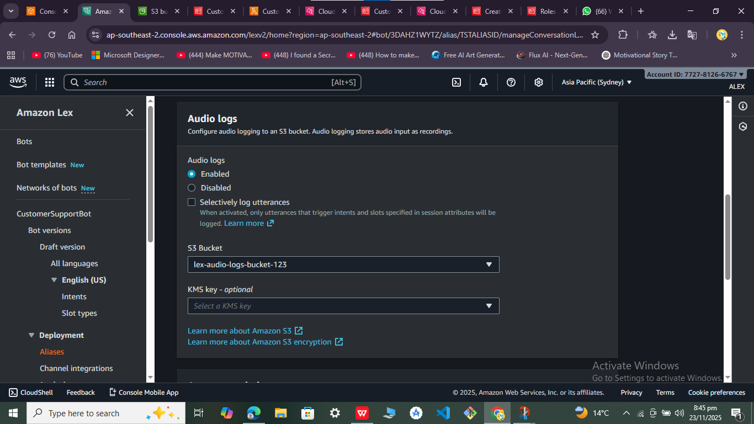

4. Rebuild and test

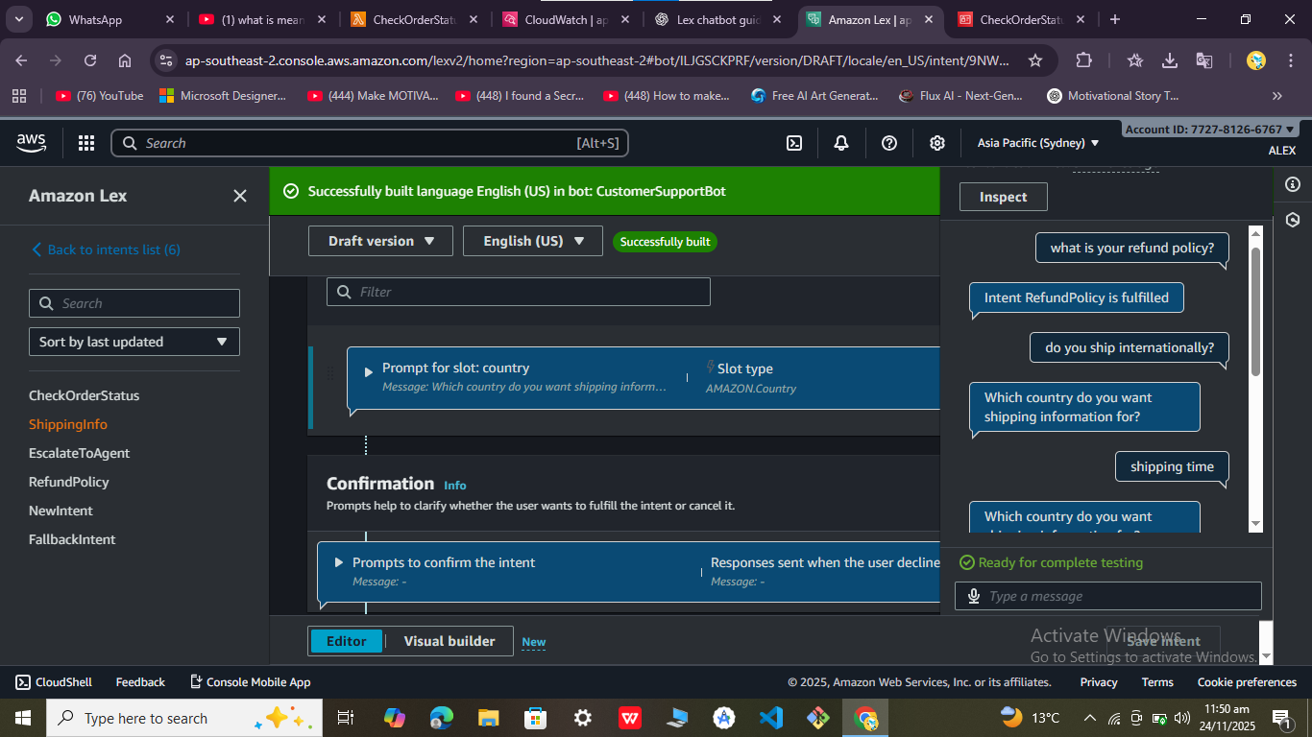

Step 2.2: Create Fallback Intent + Fallback Lambda (AI-powered responses)

Part 1: Create Fallback Intent in Lex V2

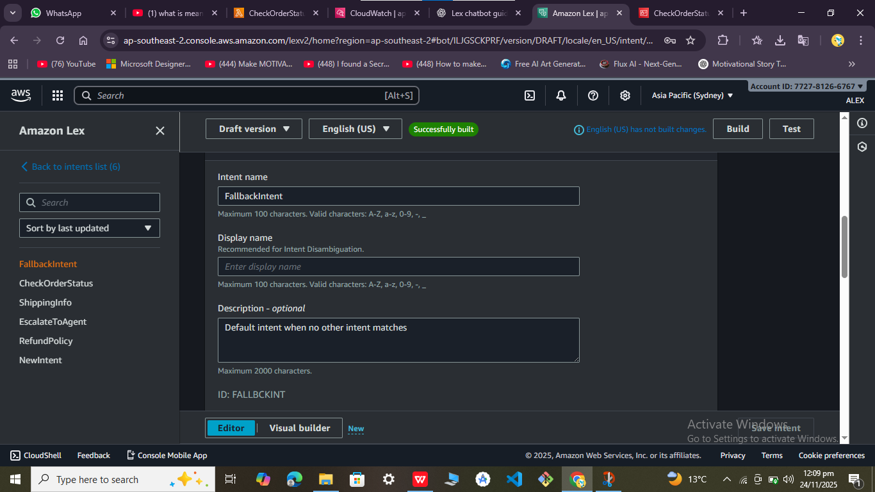

Step 2.2.1: Create Lambda Function

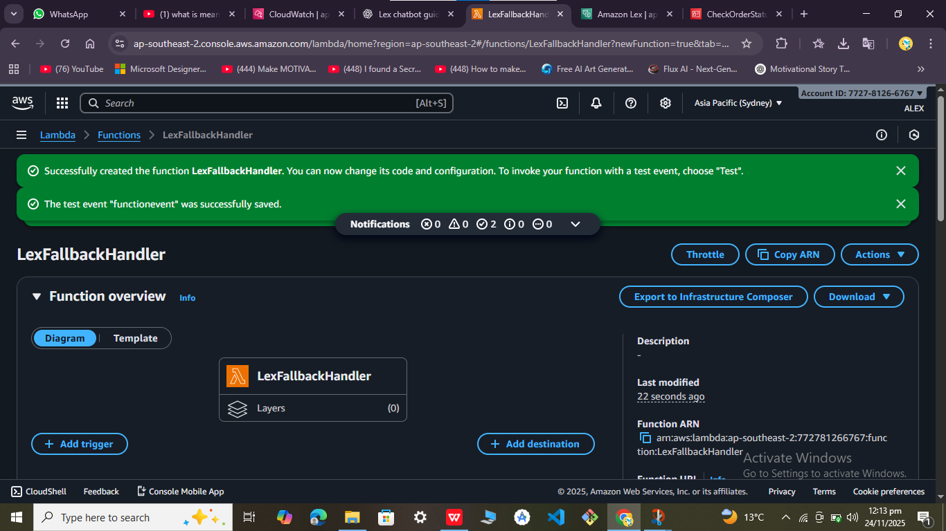

### Step 1: Get your GROQ API KeY

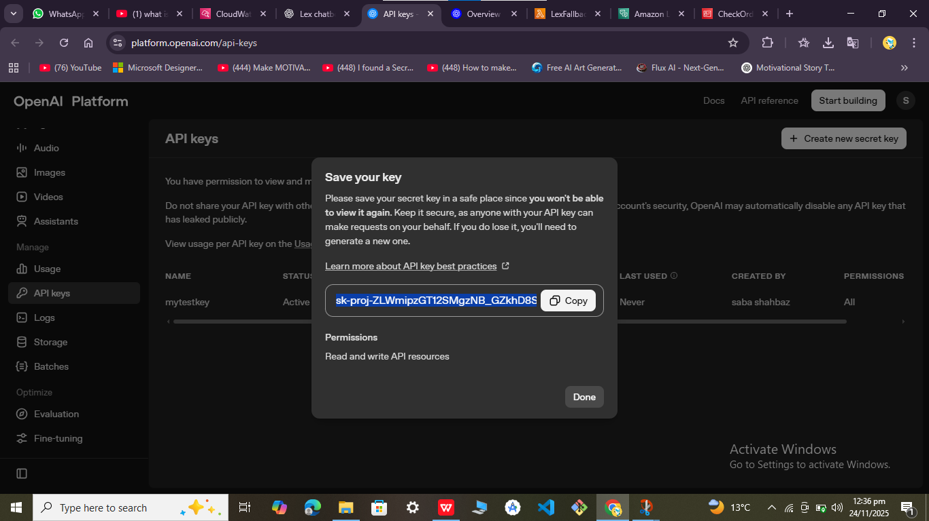

Step 2: Add the API key securely to your Lambda function

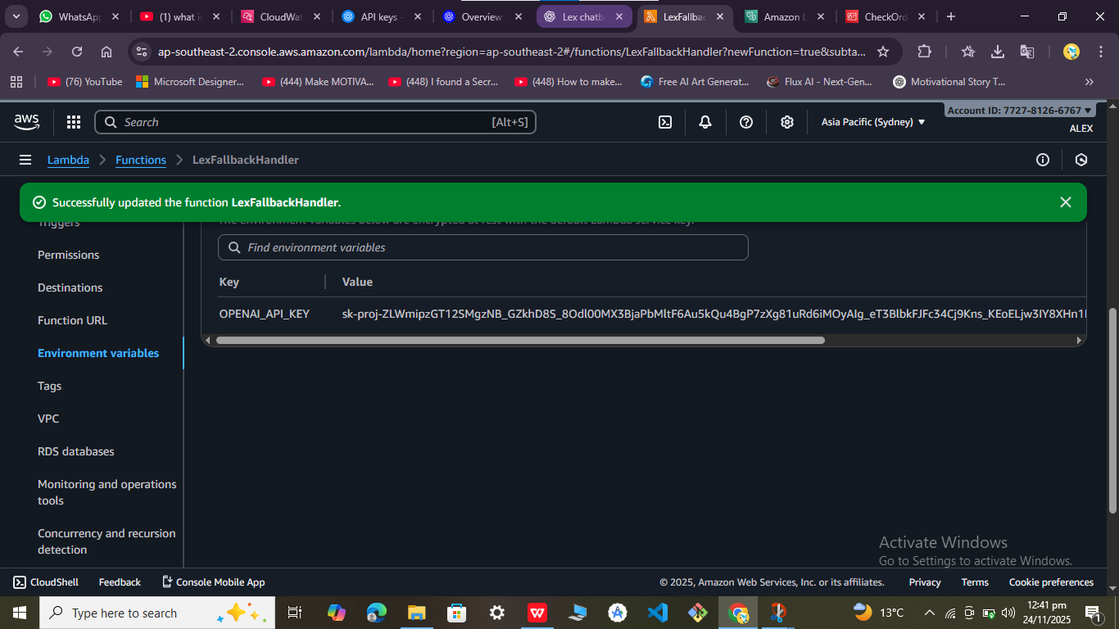

Permissions assgned:

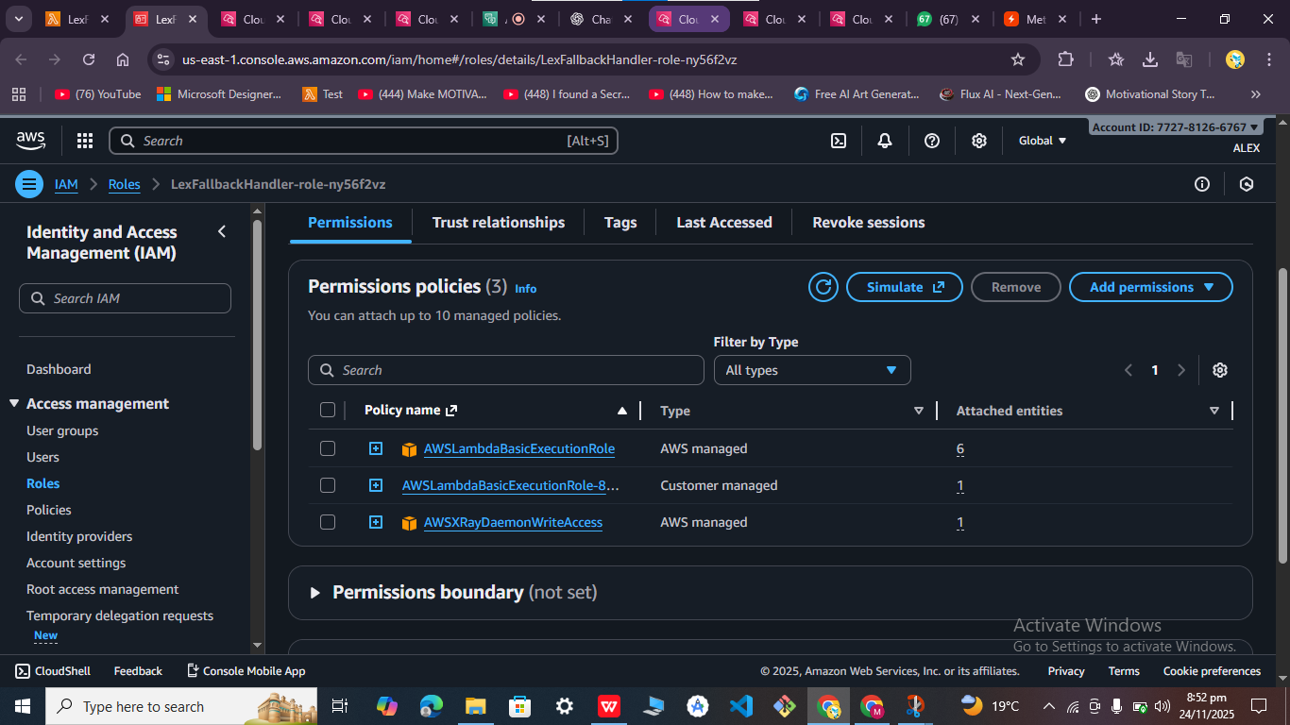

Function executed:

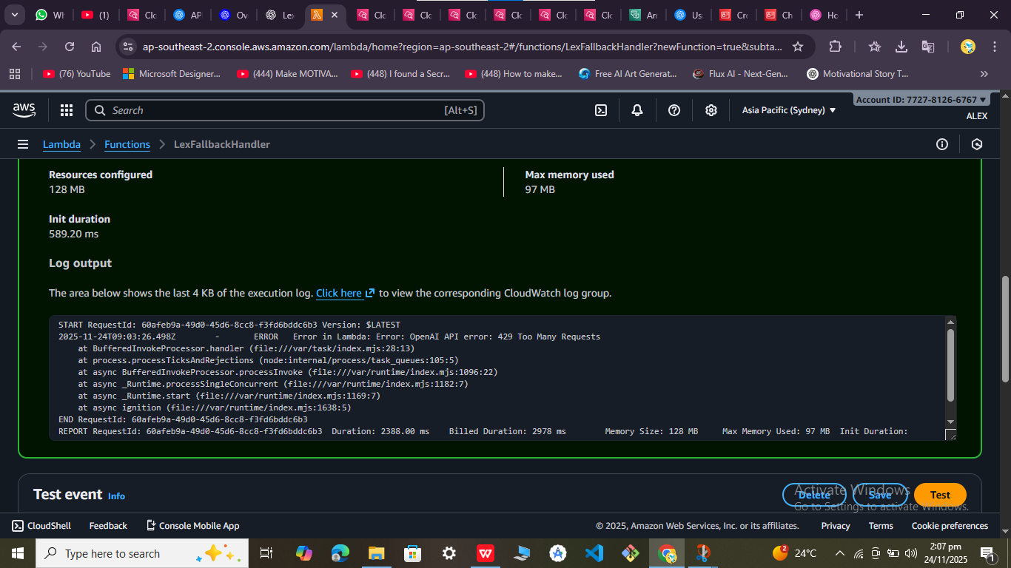

Api created:

